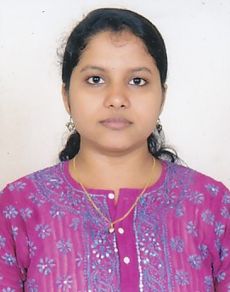
RESUME

Address: 31 B.C.Chatterjee Street
Belgharia, Kolkata-700 056.
E-Mail ID: arpita_nis@yahoo.co.in

Contact No :(0) 9903980766/9883080766

ARPITA CHAKRABORTY

Objective: To be in a challenging profession, where I can utilize my skills to share as
Well as enrich my knowledge & can put forth my best for the personal &
Organizational efficiencies.

Education: 1) Passed Master of Business Administration as well as Post
Graduate Diploma in Applied Management in 2007 from The Nis Academy a
division of NIS SPARTA the Reliance ADA Group.
2) Passed Bachelor of Business Administration from Dinabandhu Andrews
Institute of Technology &Management under West Bengal University of
Technology in 2005.
3) Passed Senior Secondary Examination from Kendriya Vidyalaya (Gujarat), under
Central Board of Secondary Education in 2002.
4) Passed Secondary Examination from Kendriya Vidyalaya (Gujarat), under
Central Board of Secondary Education in 2000.

.

Projects &
Training: Projects:
1) Minor project on the Hero Honda Company related to the S.W.O.T
Analysis, 4P’s, BCG Matrix.
2) Minor project on the Repositioning of Onida Black Television in the current
Market Scenario.
Training:
1) 6 months On-Job Training in Pantaloons Retail India Limited, on Gift Voucher Projects.
2) 2 months training from Oil & Natural Gas Corporation on performance
Appraisal rule.

Work
Experience: 1) Working with Kredent Infoedge Pvt. Ltd. as a career Adisor from 25th
January 2017 to till date.

1) Worked with Interface Destination Pvt. Ltd. As a Sales Co-Ordinator
From 15th Feb’2015 till 30th November’2015.

- Worked with One World Tele Service Pvt. Ltd as a Tele Sales Executive from 15th Feb 2014 to 14th Feb 2015.

- Worked as a Tele Sales Executive in Matrix Cellular Service International Pvt. Ltd. From 5th Jan’2013 to 9th Jan’2014.

Computer MS Office (Word, Excel, Power Point).
Knowledge:

Personal Details:.

Date of Birth: 20-09-1985.
Language Known: Bengali, Hindi, & English.
Marital Status: Married.
Father’s Name: Mr.Arup Chatterjee.

Declaration:

I herby declare that all statements made in this application are true, complete and correct to the best of my knowledge and belief. In the event of any information found false or ineligibility being detected before or after the test and interview, my candidature will stand cancelled and my claims for the recruitment forfeited.

